**Dr. Alan Appleby (April 25, 1937-October 27, 2024)**

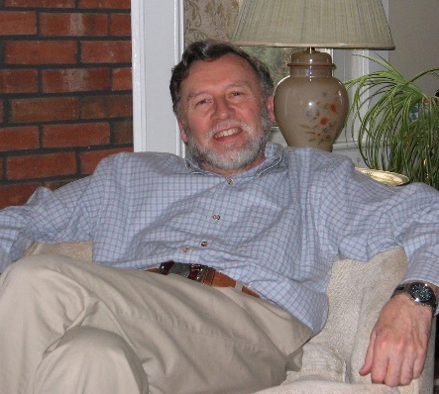

Dr. Alan Appleby was born April 25, 1937, in Newcastle, England to Henry James Appleby and Gladys Evelyn Appleby (Simpson). He was educated at the Newcastle Royal Grammar School and obtained degrees of B.B. in chemistry and Ph.D. in Radiation Chemistry in Durham University. In 1960 he married Kathleen Anne Shippen.

He was postdoctoral Fellow at Brookhaven National Laboratory in Long Island, NY from 1963-1965, a Senior Scientific Officer at the UK Atomic Energy Authority, Amersham, England from 1965-1967. In 1967 he was appointed Assistant Professor of Radiation Chemistry at Rutgers University, becoming Full Professor in 1977. In 1973 he performed the first radiation chemical studies on accelerated heavy ions at the Princeton Particle Accelerator, NJ and continued this work at Lawrence Berkeley Laboratory, CA during a sabbatical leave in 1976.

In 1989 he established the Eastern Regional Radon Training Center at Rutgers with funding from the EPA.

In 1994 Dr. Appleby was appointed Graduate Program Director of the Environmental Sciences Program at Rutgers. In 1997 he was a Fulbright Fellow at the University of Ljubljana, Slovenia. He retired from Rutgers in 1999 as Emeritus Professor of Environmental Sciences. Dr. Appleby authored and co-authored approximately 100 scientific articles and chemical effects of high energy radiations, and he developed analytical techniques for measuring radiation doses with applications to medical uses of radiation, and instrumentation for radon measurement in the environment.

Alan was a lifelong Episcopalian, having served on many committees and outreach programs, sung in the choir, served as a Eucharistic minister, licensed Lay Eucharistic Visitor and Worship leader and delegate to Diocesan conventions. He was an acolyte (altar server) at each of seven Anglican churches in UK and USA, for 80 years. He was active in choral singing with Cantabile Chamber Chorale, and served on their Board. He is survived by his wife of 64 years, Kathleen, daughters Sarah and Emily, and grandchildren Hannah, Kate, Bethany, and Alan.