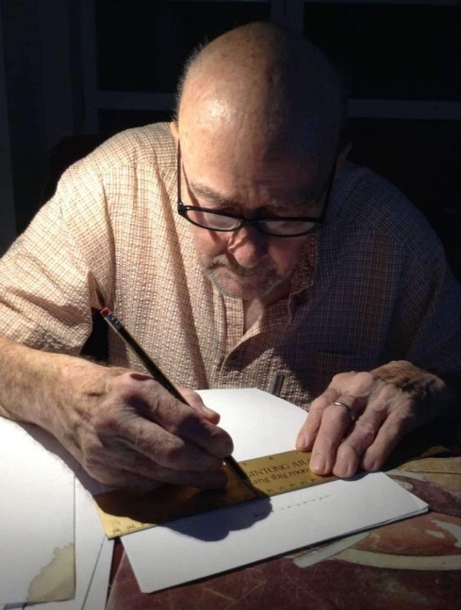
Alan Van Heuvelen, born on December 15, 1938, passed away peacefully at his home in Manila, Philippines, on August 11, 2024, leaving behind a legacy of love, strength, and unyielding spirit.
My dad’s life was that of an independent thinker with an unshakeable resilience. He got to spend many decades doing work he loved; being a Physics Professor, first at New Mexico State University, then at The Ohio State University, and finally at his alma mater Rutgers University. I can remember him starting to handwrite the first edition of his first physics textbook on yellow legal pads when I was a young girl. He always carried a notebook with him. If he ever found a minute of waiting somewhere, he would get out his current notebook and flesh out all of his “Nobel Peace Prize” ideas. Here is a link to a newspaper article about a huge Physics award he received: Millikan Medal
His most recent physics textbook, coauthored with Eugenia Etkina and Gorazd Planinsic, was ground-breaking in that it contained hyper-links to videos of experiments and demonstrations that incorporated his innovative active-learning teaching method now used around the world. The third edition of that textbook is currently being updated and prepared for publishing by his co-innovators/coauthors at this time.
A Type 1 Diabetic since the age of 14, he faced life's challenges with a courage and optimism that never wavered. Never once did he allow his condition to define him or dampen his enthusiasm for life. Instead, he embraced it as an opportunity to inspire those around him, showcasing a strength that extended far beyond any physical limitations he endured. He always told new Diabetics he encountered, “Did you know Diabetics are the most beautiful and intelligent people?”
My dad’s academics, sports (basketball was a particular passion), music (he was a classically trained violinist who took fiddle lessons and played the saw!) and professional accomplishments were numerous, yet it was his personal touch that truly set him apart.
He was a beloved husband to Vivian Dela Cruz, a devoted father to Jose Antonio Vergara, and a cherished father to Jodi Hernandez. He leaves behind three treasured grandchildren: Sarah Hernandez (Missy Bear), Samuel Hernandez, and Kaylin Hisel. Alan is also survived by his younger brother, Gary Van Heuvelen; his sister, Sally Moen; and his cousin, Bob Van Heuvelen, each of whom he held close to his heart. He is predeceased by his first wife of 38 years, Linda Van Heuvelen, son Scot Van Heuvelen, cousin John Van Heuvelen, Uncle Hiley Van Heuvelen and his parents Willis and Ragna Van Heuvelen.
My dad's legacy is not solely found in his work, but in how he made people around him feel; encouraged and special. As we remember Alan Van Heuvelen, we celebrate a life lived with purpose, a spirit that never faltered, and a heart that was always open. His memory will forever remain in our hearts, a testament to a life well-lived and a soul that inspired us all.

To give you a feel for his impact in the Physics educators community around the world, here are some comments made in response to the news of his passing:

Suzanne White Brahmia
Alan planted so many seeds in the field of PER that can be seen everywhere -- multiple representations and their capacity to include a more diverse group of learners, bar charts for building mental structures to understand conserved quantities, and so many others. Our field is so much richer for his contributions to it. He was also a really nice and fun person. I truly value having had him in my life.

Tiffany Lang Rosengrant
So sad to hear this. The world has lost a brilliant mind and those that knew him lost a wonderful friend. May he rest in peace and always be remembered kindly.

Aisling Nic Lynne
I’m completely blindsided by this news. Alan was inseparable from my experience learning to teach.

Gary White
His was one of the first physics education workshops I ever attended…revelatory and inspiring and all about the learner…he will be missed

Cathy Mariotti Ezrailson
He was a giant among physicists and taught us so much. My teaching was the better for my having learned from him! May his memory be a blessing for those who have known him!

